# Overview

In this guided practice you will verify and implement the remaining part of your Active Directory logical design.

# Objectives

* Be able to implement an Active Directory logical design.
* Be able to import Active Directory objects using the **csvde** command.

# Prerequisites

Guided practice - **Creating a New Domain Tree** is complete.

# Scenario

Now that you have implemented the Active Directory domain structure requested by ABS Corporation you will investigate and verify the operation of the logical AD components. In addition, you will use the data files provided by ABS Corporation to import the objects into Active Directory. You will then create the final logical design, the OU structure, and move the imported objects into their respective containers.

# Tasks

## Verifying the Domains and trust relationships

This guided practice requires the CIS256-RTR, CIS256-DC1, CIS256-DC3, and CIS256-DC2 virtual machines to be running.

### Viewing the Domains and Trust Relationships

1. Logon to your **CIS256-DC1** virtual machine using the **ABSAdmin** account.
2. Open **Active Directory Domains and Trusts**
3. In the left-hand pane, you will see the domains created in the previous guided practices. Verify that there are two domain trees: **abscorp.com** and **lametech.com** and there is one child domain **research.abscorp.com** below abscorp.com.
4. Select **Properties** from the context menu for the **abscorp.com** object.
5. View the information on the **Trusts** tab.
6. The top displays the **Domains trusted by abscorp.com (outgoing trusts):** and the bottom displays the **Domains that trust abscorp.com (incoming trusts):**. Notice that each location is trusted and trusting, this means that the trusts are two-way.
7. View the **Trusts** tab for the other **research.abscorp.com** and **LameTech.com** domains. You will notice that the other domains only trust **abscorp.com**.
8. Note also that all these trusts are transitive. This means that if **Lametech.com** trusts **abscorp.com** and **abscorp.com** trusts **research.abscorp.com** then **Lametech.com** will trust **research.abscorp.com.**

### Verifying the Trust Relationships

We will verify the trust relationships by logging into our servers with accounts from another domain.

1. Configure **CIS256-CLIENT1** virtual machine to use a basic session instead of an enhanced session. (Enhanced sessions require users to be in **Remote Desktop Users** or **Administrators** group on the local system.)
   1. On the Virtual machine, select the **View** menu, and then uncheck **Enhanced session**.
2. Logon to the **CIS256-CLIENT1** virtual machine using the **Research\RNDAdmin** account from the **Research** domain to **verify** that **ABSCorp** **trusts** accounts in the **Research** **domain**.
3. Once you have verified that you can logon, logoff the machine.
4. Logon to the **CIS256-CLIENT1** virtual machine **using** the **Lametech\LTAdmin** account from the **Lametech** domain to **verify** that **ABSCorp** **trusts** accounts in the **Lametech** domain.
5. Once you have verified that you can logon, logoff the machine.
6. Move the **CIS256-CLIENT1** VM to **Pickens** switch and logon with an account from **Charlotte** using the following procedure:
   1. Change your **CIS256-CLIENT1 network adapter** settings so that it is **connected** to **Pickens virtual switch**.
   2. Logon to the **CIS256-CLIENT1** using the **Research\RNDAdmin** account.
   3. Verify that you have the IP address settings from the DHCP server in Pickens.
   4. Logout of the **CIS256-CLIENT1** virtual machine
   5. Reconnect the **CIS256-CLIENT1** virtual machine's **network adapter** to **Greenville** virtual switch.

## Creating the Organizational Unit Structure

1. Download the **CIS256-ABS-Greenville-Employees.csv**, **CIS256-ABS-Pickens-Employees.csv**, and **CIS256-Charlotte-Employees.csv** files to the **desktop** of your **home** or **school** computer where you have access to **Microsoft Excel**.
2. Open the **CIS256-ABS-Greenville-Employees.csv** file in Excel. **Identify** all the **departments** in the Greenville location.
3. Logon to the **CIS256**-**DC1** virtual machine. **Open** **AD Users and Computers** and **create** **OUs** for the following **departments** at the root of the domain: **IT, Management, Projects,** and **Sales**
4. Repeat the **steps** above **to** **create** **OUs** for the **Charlotte** (CIS256-DC2): **Engineering, IT,** and **Management** and **Pickens** (CIS256-DC3) location: **Management, Projects, Sales,** and **Services.**

## Importing the AD Objects

The **CIS256-ABS-Greenville-Employees.csv**, **CIS256-ABS-Pickens-Employees.csv**, and **CIS256-Charlotte-Employees.csv** files contain employee information obtained from ABS Corporation and will be used to import the user accounts into Active Directory.

### Identifying Mandatory Attributes and their Names

1. **Logon** to the **CIS256-DC1 (ABSDC)** virtual machine with the **ABSAdmin** account.
2. **Open** **Active Directory Users and Computers**
3. Turn on the **advanced view** by **selecting** the **View** menu and selecting **Advanced Features.**
4. **Browse** to the **Users** **folder** and **double-click** the **ABSAdmin** account to view its **properties**.
5. **Select** the **Attribute Editor** tab. This tab displays the names of the attributes for this user account.
6. **Click** on the **filter** button and click the filters until the **only check is next to mandatory attributes**. This will display the minimum attributes required to create a user account.
7. List the mandatory attributes in the table below:

|  |  |
| --- | --- |
| **Attribute Name** | **Value** |
|  |  |
|  |  |
|  |  |
|  |  |
|  |  |
|  |  |

### Determining Additional Attributes

The employee files also include information about the user’s department, city, state, first name, and last name.

Use the following procedure to determine the Active Directory attribute name associated with each piece of data:

1. Create a new **user** called **John M Doe** with a **logon** **name** of **jdoe.**
2. After the user is created **open** the **properties** page for the account and **type** the word **department** in the **department** textbox in the **Organization** **tab** and **click** the **Apply** button.
3. Configure the following additional properties **on** the **Address** **tab**:
   1. City – **City**
   2. State – **State**
4. Change to the **Attribute Editor tab** and **change** the filter so that it shows **Mandatory** and **Optional** values but only the **ones that have values**.
5. **Find** the **attribute name** that has the **value Department** in it. **Note**, the attribute name is in the left-hand column and the value is in the right.
6. Use the procedure above to fill in the table below:

|  |  |
| --- | --- |
| **Employee Data** | **Attribute Name** |
| First Name |  |
| Last Name |  |
| Department | department |
| City |  |
| State |  |
| Logon Name (looks like an email address) |  |
| Pre-Windows 2000 Logon name |  |

### Creating the CSV file

In this step you need to modify the CSV file so that it is in the proper format. Use the following steps to do this:

1. **Open** the **CIS256-ABS-Greenville-Employees.csv** file in **Excel**.
2. The first line of the CSV file must contain the attribute name for the values that are in that column. Previously we determined that the user’s department was stored in an attribute named department so in the first row the word department would be above the column for the department names.
3. Repeat the previous step for all the attribute names identified in the previous step e.g. the attribute name for a user’s first name is **GivenName**, so you would replace “First Name” with **GivenName**.
4. Add the following additional columns: **ObjectClass**, **UserAccountControl**, and **DN**.
   1. These can be used to specify that this object is a user (**ObjectClass** = **user**), enable an account (**UserAccountControl** = **512**), and set the location of the object (**DN**,**DistinguishedName**).
5. Some attributes have no values and so must be calculated from other values. This can be done by using a few simple formulas in Excel and the concatenate (&) operator.
6. We will do this for the Pre-Windows 2000 Logon name (**sAMAccountName**). In the first row, make a column with **sAMAccountName** at the top. In the column below this row type the following formula:

=Left(A2,2) & B2

* 1. This is assuming that the first name is in the cell A2 and the last name is in cell B2. What this does is take the value A2 and remove 2 characters starting at the left and then concatenates (adds) to the value in cell B2. This will create your First Two Initials + last name username.

1. **Add** **two** columns with the headings **displayname** and **cn**.
2. In the rows below the **displayname** and **cn** headings, **add** the **formula** below

=A2 & “ “ & B2

1. **Create** a **column** for the **mail** and **userprincipalname** attributes. The formula below will create a value for the email attribute and the **UserPrincipalName** attribute. (**Note**: adjust the formula as necessary if I2 does not contain the **samAccountName** attribute.

=I2 & “@abscorp.com”

1. In the **ObjectClass** column, the value should be **user** for all lines
2. In **DN** column you can use the following formula to create it using the value in the displayname column assuming that displayname is in the J column

="CN=" & J2 & ",CN=Users,DC=ABSCorp,DC=com"

1. In the **UserAccountControl** column enter **512** for all lines.
2. **Save** your **file** as an **XLSX** document to preserve your formulas.
3. **Save** your file **again** **using** the **CSV** format.
4. **Upload** your **CSV** file **to** **OneDrive** **or** **other cloud storage** and **download** it to the **desktop** on your **host** machine.

## Importing Active Directory Objects using the CSVDE utility

Objects imported using the **csvde** utility have blank passwords. Since this is not allowed by the default password policy, we must change the policy to allow blank passwords. You will then import the users and when you are finished, you will return the password policy to normal.

### Change the Password Policy

To change the password policy to allow for blank passwords perform the following:

1. Logon to the **CIS256-DC1** virtual machine using the **absadmin** account.
2. Run the following command to reset the password policy.

Set-ADDefaultDomainPasswordPolicy -Identity abscorp.com -ComplexityEnabled $false -MinPasswordLength 0 -Credential abscorp\administrator

### Import the User accounts

1. On the **CIS256-DC1** virtual machine verify that you are connected to the VM using an enhanced session.
2. Logon to the **CIS256-DC1** virtual machine using the **absadmin** account.
3. On your host machine **copy** the **CIS256-ABS-Greenville-Employees.csv** file and **paste** it to the **desktop** on the **CIS256-DC1** virtual machine. **Rename** the file **employees**.**csv**.
4. Open PowerShell as an Administrator and type the following:

csvde -i -k -f C:\users\absadmin\desktop\employees.csv -j .

1. You should see a screen like the following below:

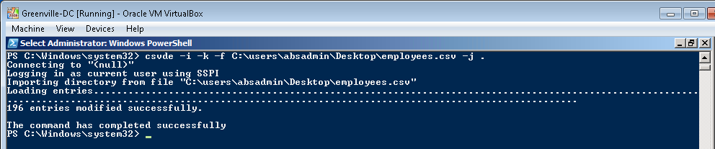

1. Type the following to open the error file **csv.err** using notepad.

Notepad csv.err

1. These are users that were not imported due to name conflicts. We will ignore them here but in real life you would resolve the conflicts and add the users.
2. **Repeat** the steps **above** for the **Charlotte** and **Pickens** employees with the following notes:
   1. The csv files have already been modified so that they can be imported directly.
   2. Remember to modify the password policy for each domain before importing them.
3. Reset the **password** **policy** on all domains to require complexity and at least 7 characters.

## Organizing the Objects in Active Directory

In this step you will modify Active Directory Users and Computers so that it displays the user’s department attribute. You will then select the users from the same department and move them to the appropriate organizational units.

### Configuring AD Users and Computers to display the Department attribute

1. Logon to the **CIS256-DC1** virtual machine as the **absadmin**.
2. Configure the **Department** attribute to be displayed as follows:
   1. 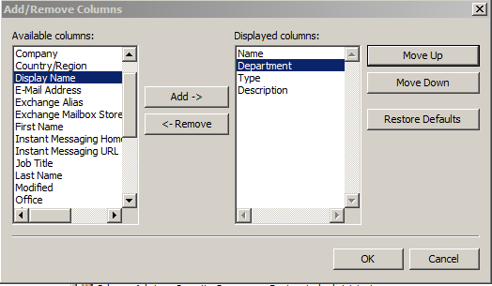Open **AD Users and Computers** and **browse** to the **Users** folder.
   2. Choose the **Add/Remove** **Columns** options from the **View menu**.
   3. Choose **Department** from the **Available columns** and **click** the **Add** button.
3. Verify that **Department** is **selected** in the Displayed columns and **click** the **Move** **Up** button until **Department is** the **second** item from the top.

### Sorting Users in AD Users and Computer and Moving Multiple users simultaneously

1. In **AD Users and Computers** browse to the **users** folder and **click** on the **Department column** to sort the objects by department
2. **Delete John Doe** user you created earlier.
3. To move the users to their respective OUs, perform the following:
   1. **Select all** the users in the **IT** department.
   2. **Right-Click** and **select** **Move** from the context menu.
   3. **Browse** to the **IT OU** and **click** the **OK** button.
   4. Repeat for the remaining departments.
4. Repeat this for the **Charlotte** and **Pickens** domains.

## sUBMISSION rEQUIREMENTS

1. **Download** the **grading** **script** from the assignment page to the **C:\Scripts** folder.
2. Check your lab by running the following command:

Invoke-Pester -Path C:\Scripts\GP08-Implementing_an_AD_ Logical_Design.test.ps1

**Note**: You will see a security warning when running the script. Enter **R** to run the script.

If you want to see more detail, add **-Output Detailed** to the command. This may assist you with troubleshooting

Invoke-Pester -Path C:\Scripts\GP08-Implementing_an_AD_ Logical_Design.test.ps1 -Output Detailed

1. You should not see any red in the output. Red in the PowerShell way of telling you that an error condition exists. Most of the time, the output will tell you what is wrong. If it is not obvious, contact your teacher and ask for assistance. You will be learning PowerShell during this term. **Correct** any **errors** you may have and run the script until all the output has no red. You should see the output like the images below.

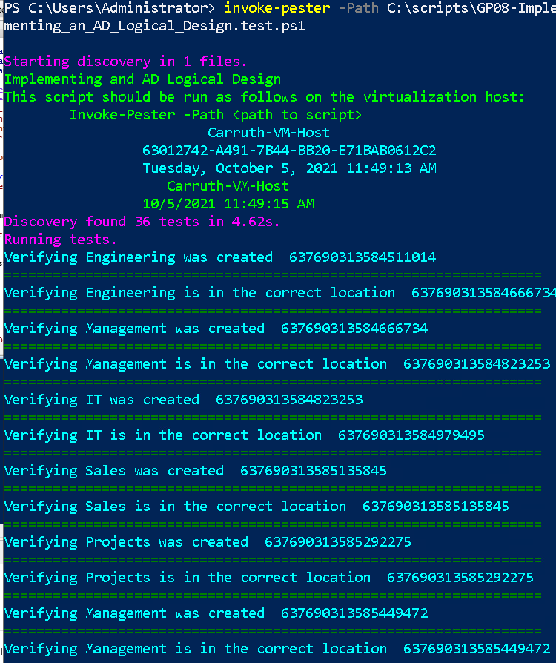

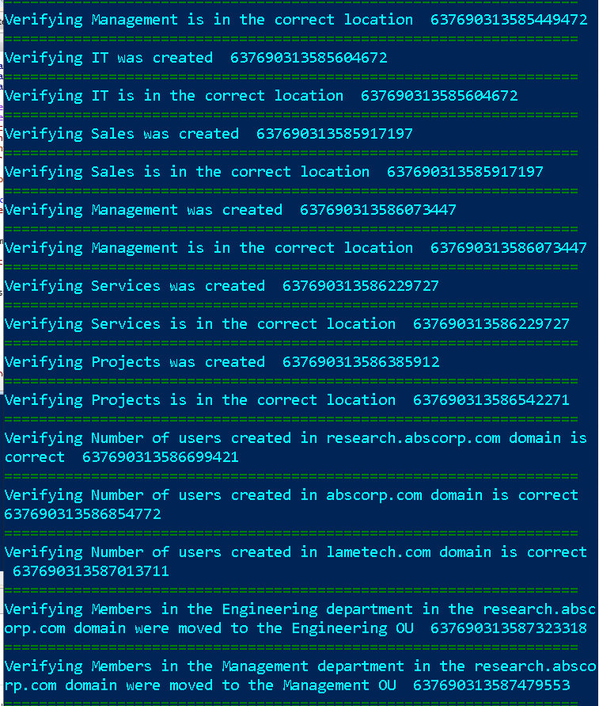

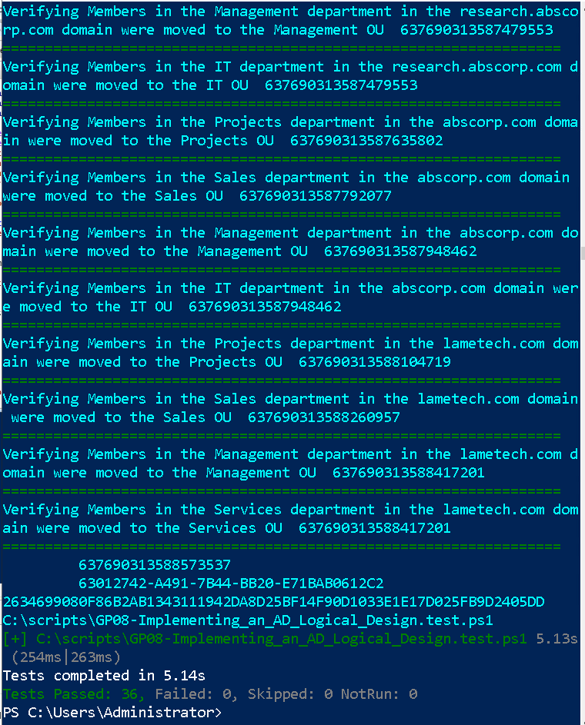

1. 3. Capture a snippet that shows the PowerShell Command and all its output. If you must use more than one snippet to capture the output, you must have at least **one line of overlap** in the snippets. The text in the snippets **must be legible** when pasted into the Word document. Paste the snippet(s) into a **new** **Word** **document.**
2. **Upload** the **document** in the submission area for the assignment.